[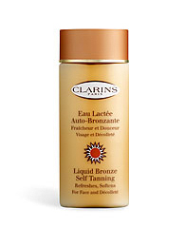](http://us.clarins.com/webapp/wcs/stores/servlet/beauty-products_self-tanners_liquid-bronze-self-tanning_C040101002_10051_10204_-1_23977_10375_10373)